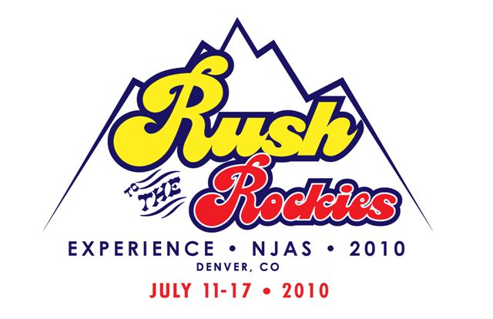
2010 NJAS

Our young Angus breeders travel many miles to compete the showring and a wide variety of educational and leadership activities including public speaking, cook-off, quiz bowl, photography, creative design, writing & team sales contests; scholarship and mentoring programs and more . There are many ways you can help sponsor the world’s largest junior beef breed show. Below is a list of areas that need your financial support:

_____Exhibitor Gift Sponsorship - $20,000
Name & logo on gift, full page 4 color ad in the program, advertising on the big screen, signage at show ring, booth space & VIP parking

_____Platinum Sponsorship - $10,000 +
Includes sponsorship of meal, sponsorship of class, full page 4 color ad in program, advertising on big screen, booth space & VIP parking

_____Gold Sponsorship - $5,000+
Includes class sponsorship, full page 1 color ad in program, ad on big screen & VIP parking.

_____Silver Sponsorship - $1,000+
Includes class sponsorship, ½ page black and white ad in program & ad on big screen

_____ Bronze Sponsorship- $500+
Includes class sponsorship, listing in show program and ad on big screen.

_____Class Sponsorship - $100 which includes advertising on screen during show. 150 available.

_____Meal Sponsorship – Breakfast will serve 1000 people, lunch will serve 1,500 & dinner will serve 2,000

_____Program Ads – Full Page B/W $750 , ½ Page B/W $500 ¼ Page B/W $250 + One Color $100 + Full Color $300

_____In-Kind Contributions

_____Trade Show space available

All sponsors will be recognized throughout the event and listed in the show program according to their specific contribution.

I am interested in providing the following:
$__________ for ________ _____________.
Please have the chairman of this committee contact me.
Check enclosed, payable to NJAS 2010.

Name ______ __Business_____________________________________

Address_____________________

Phone_________________ __ Email

- Sponsorship Opportunities –
Tiered Sponsor
Those interested in making a monetary contribution to the 2010 National Junior Angus Show can do so by utilizing the Tiered Sponsorship levels. Choose among five levels for financial contribution. Platinum and gold sponsors are eligible for 1 complimentary full page ad in the page ad in the show program. (See the reverse of this page for detailed tiered sponsor benefits.) All sponsors will be recognized throughout the event and listed in the show program.
Platinum - $10,000 +
Gold - $5,000 - $9,999
Silver - $1000 - $4,999
Bronze - $500 - $999
Class Sponsor - $100 each
Class Sponsors will receive a Power Point Presentation advertisement during the assigned sponsored class in which the farm/company can advertise by using full color photos, graphics, etc. Please send promotional pieces and design ideas to be used to Jud Hoffschneider, 16185 CR 7, Arlington, NE 68002 (scotth@2riversbank.com) by April 1, 2010.

10% of Lot # 10 for 2010
Commit 10% of the sale of lot #10 in your fall of 2009 or spring 2010 sale. Sale name and date with a link to your sale book, website or email will be posted on the NJAS website. The committee with provide you with the 2010 NJAS logo if you wish to place it in your sale book. Recognition with be given based on your donation, see sponsor levels above. Contact Anne Lampe if you wish to participate. alampe@wbsnet.org, 620-872-3915.

Embryo Lottery Ticket Chances - $100 each
Elite Angus embryo packages have been donated by leading breeders across the country to help raise funds for the 2010 National Junior Angus Show. Individuals have the opportunity to purchase lottery tickets for $100 for the chance to win a great package. Only 1,000 tickets will be sold. Random drawings will be held in conjunction with the 2010 National Junior Angus Show, July 11th – 17th. All embryo packages will be stored at TransOva Genetics in Sioux City, Iowa. Cost and risk of shipment and implantation of embryos is the responsibility of each winner. There is no guarantee by the show committee, project volunteers, sponsors or TransOva Genetics that a pregnancy will result in any of the embryo packages. For more information on all embryo packages offered, visit www.njas.info

Meal Sponsors
Feeding groups of this size during the 2010 National Junior Angus Show will certainly be a big task. Meal sponsors can make a financial contribution or supply food product to be prepared by the NWSS concessions. It is estimated that each breakfast meal will serve 1,000, each lunch will serve 1,500 and each evening meal will serve 2,000.

In-Kind Contribution
Between welcoming guests and greeting them with western hospitality to serving meals, providing a hospitality area, decorating the entire venue, to showcase Colorado, Kansas and Nebraska, there are so many ways to provide in-kind contributions to the 2010 National Junior Angus Show. The show committee is seeking food items and serving products, beverages, ATV vehicles, promotional products, logo items, children’s items, plant materials and just about anything else you can think of.

NJAS Program Advertisements
What better way to reach a market of progressive seedstock producers and agricultural enthusiasts than to advertise in the 2010 National Junior Angus Show program. This program is seen by every spectator at the NJAS and becomes a lasting piece of literature for most Angus families. The show program will feature all show information including entry information, exhibitors, show details and event times, honorees and advertisements from breeders, agricultural groups and businesses. Ad sales will be kicked off with the sell of premium pages during the American Angus Association Annual Reception in Louisville, KY and all remaining pages are currently available. Ad deadline will be May 1st.

NJAS Trade Show
The 2010 National Junior Angus Show will feature a trade show area in which exhibitors can showcase their agricultural and non-agricultural products, supplies and information. This event will be a great place to be seen by more than 5,000 people from across the country!
All sponsorships and sponsorship contracts should be turned into the 2010 National Junior Angus Show office no later than April 1, 2010, unless otherwise noted. Please submit contributions and checks payable to:
2010 National Junior Angus Show
Scott Hoffschneider (scotth@2riversbank.com)
16185 CR 7, Arlington, NE 68002

